**How to use the "htop"**

1. Installation: If it's not already present, install htop using your package manager:
   * Ubuntu/Debian: sudo apt install htop

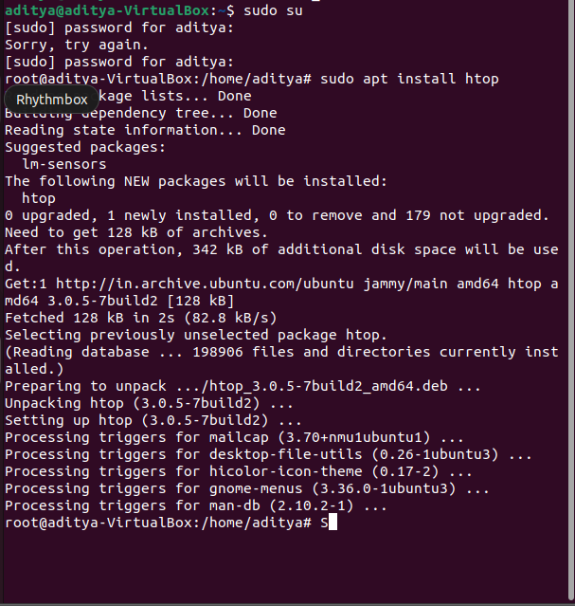

1. Launching htop: Open a terminal and simply type htop.

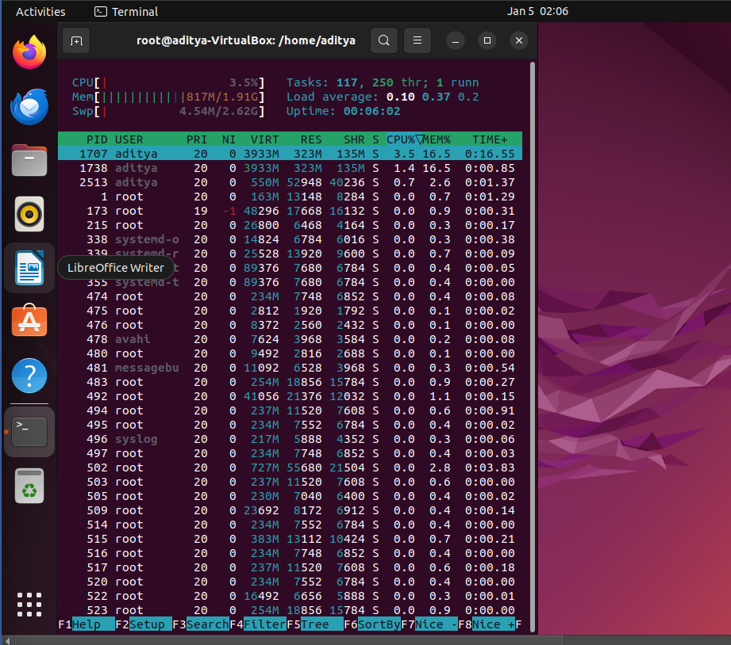

**Understanding the Interface**:

* Top Section:
  + CPU Usage: Graphical bars for each core, indicating usage percentage.
  + Memory Usage: Total memory, used memory, free memory, and swap space.
  + Load Average: Average CPU load over the last 1, 5, and 15 minutes.
* Process List: A table of running processes with details like:
  + PID (process ID)
  + USER (owner of the process)
  + PRI (priority)
  + NI (niceness, a measure of willingness to give up CPU time)
  + VIRT (virtual memory size)
  + RES (resident memory size)
  + SHR (shared memory size)
  + S (process status: R = running, S = sleeping, T = stopped, Z = zombie)
  + %CPU (CPU usage percentage)
  + %MEM (memory usage percentage)
  + TIME+ (total CPU time used by the process)
  + COMMAND (name of the process)
* Footer: Help bar with interactive options and function keys.

**Key Features**:

* Real-Time Updates: htop displays information in real time, so you can see changes as they happen.
* Interactive: You can interact with processes directly within htop:
  + Kill processes (F9 or k)
  + Change priority (F7 or n)
  + Search for processes (/)
  + Filter processes by user (u)
  + Sort processes by different criteria (p for CPU, m for memory, t for time)
* Customizable: Customize the display by:
  + Choosing which columns to show (F2)
  + Highlighting processes (spacebar)
  + Adjusting colours and layout (F2 -> Display options)

**Real-Time Examples**:

1. Identifying Resource Hogs: Sort processes by CPU usage (p) to see which processes are using the most CPU resources. Investigate and address high-usage processes if necessary.
2. Monitoring Memory Usage: Keep an eye on memory usage to prevent slowdowns or crashes. Explore options like closing applications or adjusting memory settings if memory is running low.
3. Troubleshooting Performance Issues: Use htop to pinpoint processes causing performance problems and take appropriate actions, such as killing or adjusting them.
4. Understanding System Behaviour: Regularly monitor htop to gain insights into your system's resource usage patterns and identify potential bottlenecks or optimization opportunities.